I wll give you a bonus of 50 pounds when these modifications and additions are done.

1. Logo must be replaced and indicating number for **number of comments** on that site must be added **to the logo** ( the indicating number loads a little after the site is loaded so you anticipate whether the logo is there or not.
2. No Information about who submitted the comment should be stored for the future.
3. the "read more"button should be after the text
4. the read more button should hide text after 350 characters including spaces.

1. The downvote button number is partially hidden now by being cut off on the right It should be fully visible.
2. when someone enters long words like ddddddddddddddddddddddddddddddddddddddddddddddddddddddddddd or the like, the box must not be extended to infinity, but rather the text must continue on the next line unless the box is increased in size manually. So there needs to be a standard width of the box to begin with. Perhaps this can be remembered from session to session like colour mode.

The logo and the advertisement must not be stretched when resizing the comment box

comment section must be able to be resized from all sides. not just bottom right corner.

also the resizing should work more conventionally where you drag the sides of the box in the direction you want.

"Be the first to comment" text on the text field if no other person has commented on a page.

Have the text field expand and take up more space as you type more. so if you type alot the whole box will be showing only your comment if you dont scroll up.

show adverisement button stays above the text input field and doesnt move.

the exposing of the advertising does not expand the add on box size but the area over the text input field and below the latest comment is of a fixed size the same as the advertisement. the text show advertisement turns into hide advertisement when the ad shows.

in night mode the scroll bar for the comments must be a red vertical line with a red scroll button shaped like a track and field running field. so two rounded ends with long sides. long sides pointing downwards . solid coloured. so like a pill shape. same shape for the day version but with the corresponding colours.

enter should allow you to post.

Enter brings you back to daylight mode. It should not change mode when clicked.

when clicking the addon button and opening the comment section, one must not be exposed to day version when it is night. Either it brings up the last mode you had open, follows your clock somehow, or you get to chose before it opens. I think last version is the best.

text must not cover the like and dislike button

The previous comments should not appear as suggested input text over the text input field.

Use logo and slogan from bottom of text box on the top as well

Implement the movable box and the side bar box (like bookmark and history sidebar button from second screenshot

In the middle colour mode, the text can be slightly darker grey, but still legible.

Indicator that there are comments on this page in add on button in menu bar. Either just a dot or change in logo or an indicator number preferrably. I can send more detailed logo drawing. the logo changes a little after the page is loaded so its like facebook and snapchat where people anticipate whether there are comments or not.

Chat function need smiley faces. emoticons. A button you click and you see the available icons. they appear as a list grid and you scroll down like you do with the comments to find the one you want. you click it and it gets incorporated into the text iinput field where you have the marker. You are able to input text while the emoticon menu is open. You can add multiple emoticons and to collapse the emoticon menu you have to click outside the emoticon menu or click the emoticon button again.

less delay in text appearing after colour change.

Some central way of deciding what advertisements should be shown should be accomplished. A default add can be chosen and a list of urls can be used to display a certain ad on certain websites. so all websites have x as advertisement. websites 1 2 3...45 have this advertisement.

small text above text imput area and below show advertisement text. It should read: Do you want your advertisement here? email Ads@asdf.com (use this email now. Will change in the future.)

links can be posted in the comment box

Links to images can be posted and a small version of the picture is viewable in the comments. If clicked it expands quite a bit more. (for seeing details in pictures people post) Link is visible and clickable while picture is big or small mode. link perhaps underneath image when in big version and small. Small image small enough so it doesnt disrupt peoples reading experience, but large enough to be viewable.

comment box doesnt minimise when clicking outside the box. Or if it is inevitable, then the sidebar solution can remedy this. So you can switch between floating box or sidebar. btw sidebar can be extended and minimised as well.

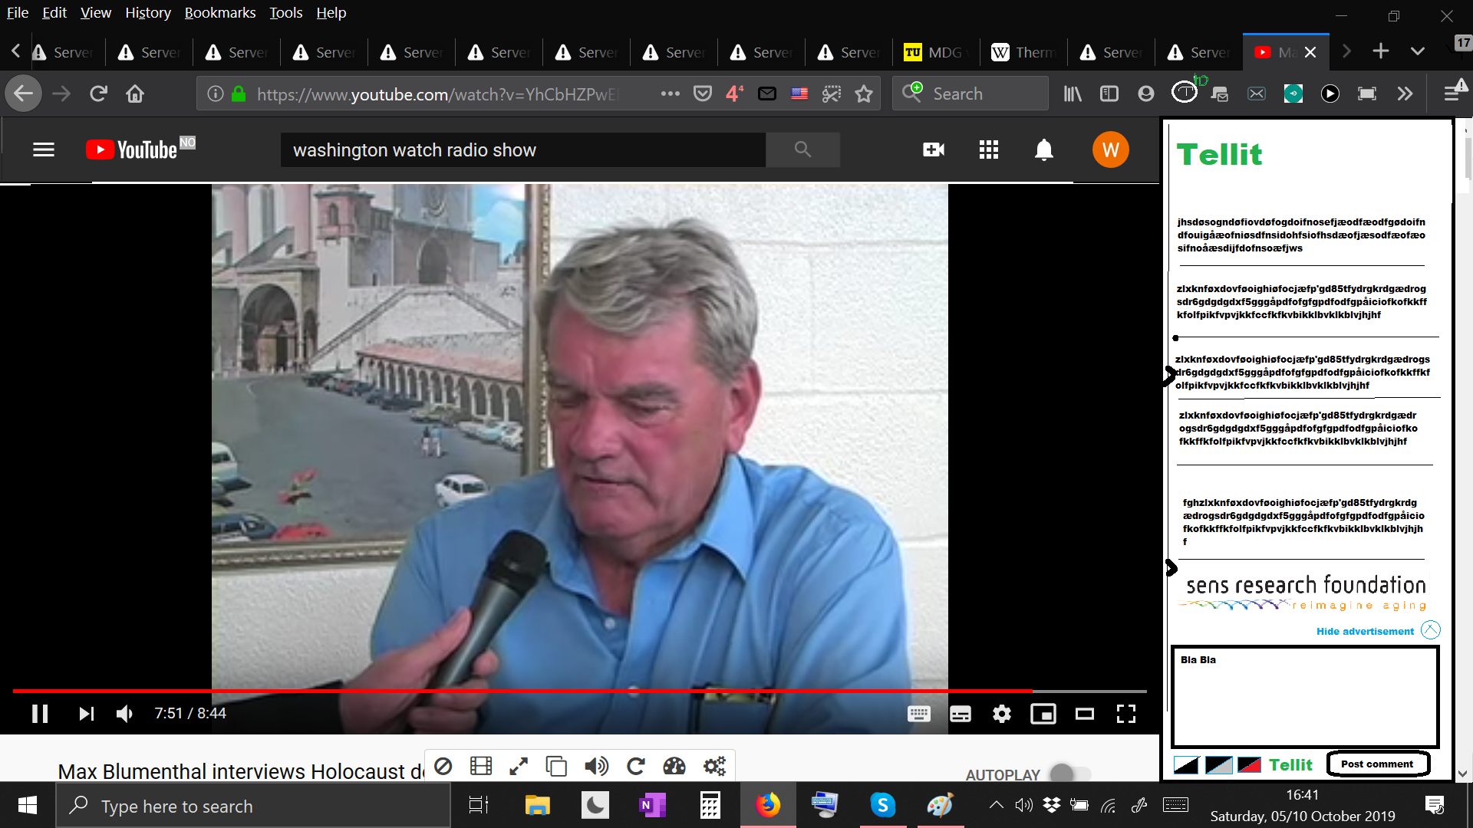

when add on button is pressed, you can immediately write text on the text input area. like google home page.

Logo is a work in progress and I am still thinking about it.

Colour mode buttons will have text hovering over them. So it will be "day mode" "night mode" and the middle one will become "troll mode" The two others stay as they were. Troll mode will get a dark green background with white text.

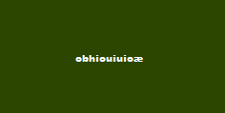

like this.

Middle button will get a small image of a troll in stead of the box that is there now.

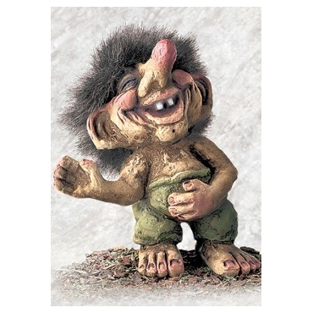

this can be used and shrunk to a size that you still see it is a troll. it can be bigger than the two other buttons for night mode and day mode.

normal comments made in day mode or night mode appear white with black text even in troll mode.

Comments posted in troll mode have green background and white text in day mode and this background sort of fading in. just his face.

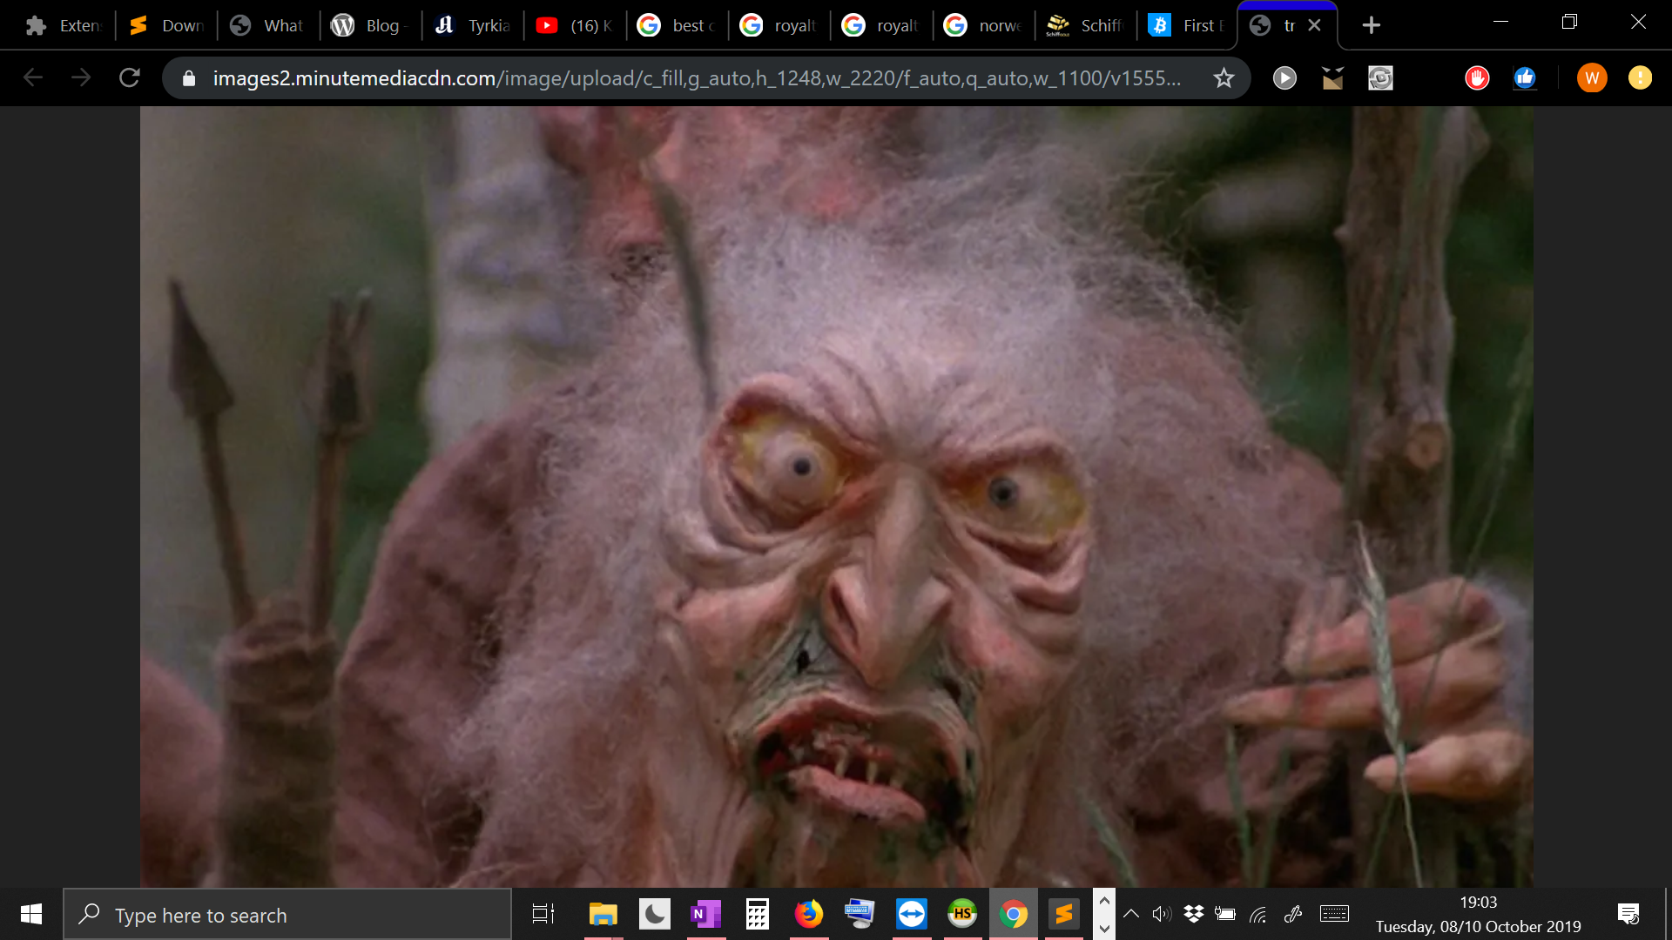

a tool in gimp or photoshop can extract the main features of the face. the face can slightly fade in. in the green troll comment backgrounds, it comes through. In night mode the troll comments made in troll mode have troll face fading in in red.